MILESTONE # 3

CSE-403L
Database Management System Lab
GROUP MEMBERS:
OMER KHAN (22PWCSE2130)
NAVEED AHMED (22PWCSE2165)
JAMAL KHAN (22PWCSE2203)
Section: B

“On my honor , as student of University of Engineering and Technology, I have neither given nor received unauthorized assistance on this academic work”

Signature: _____________________________________ Date: June 2, 2025

Submitted To: Engr. Sumayyea Salahuddin

Department of Computer Systems Engineering University of Engineering and Technology

REQUIRED:
Dear Students,
Please submit your project database showing all the tables, metadata, keys, data, and queries in .docx format and not in pdf format. Also, submit .sql file containing your project database.
Thank you.
DATABASE:
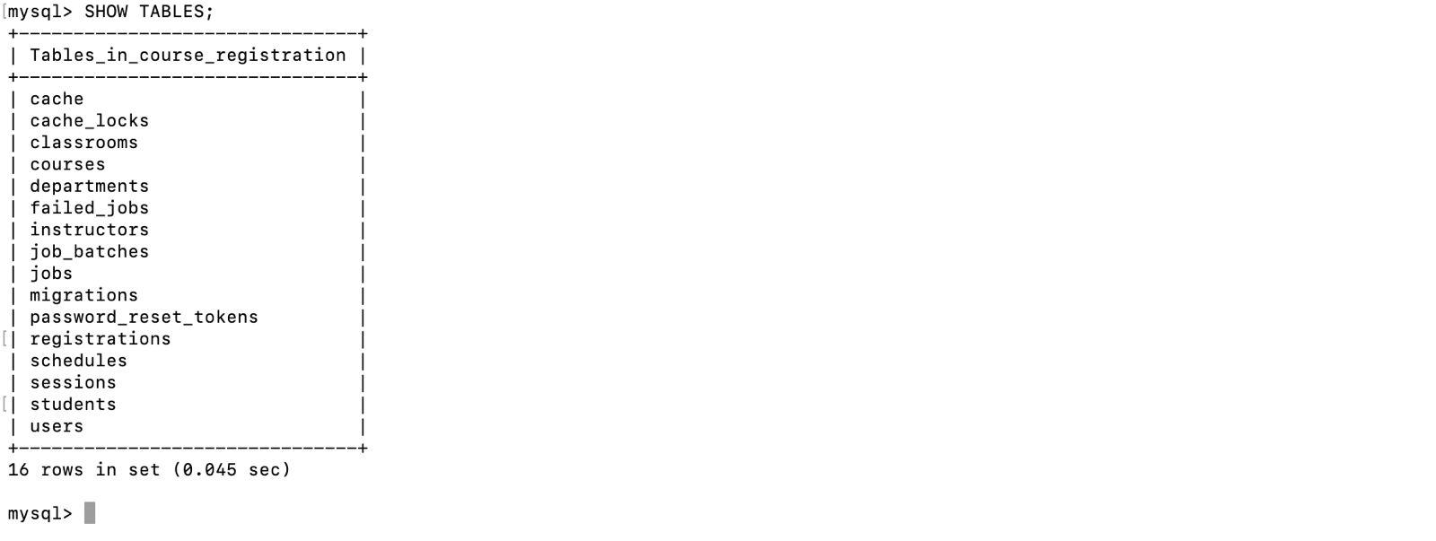
TABLES:
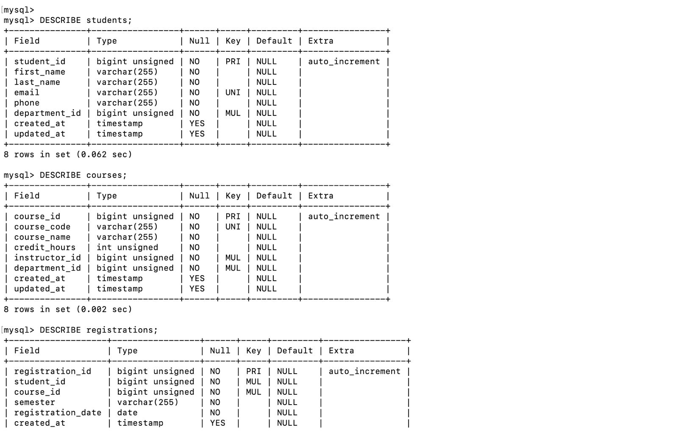

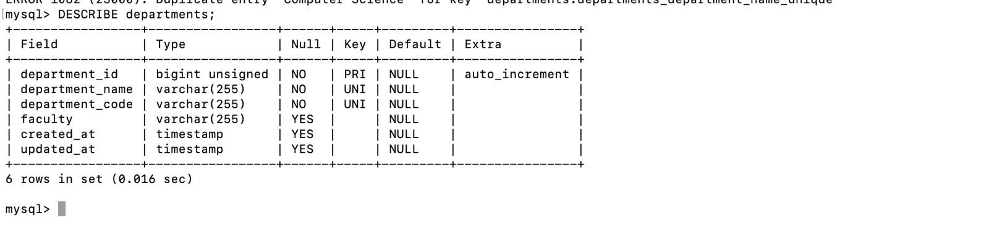

METADATA:
